CRYPTOGRAPHY AND SYSTEM SECURITY
6. Web Security
6.1 Web Security Considerations, User Authentication and Session Management, Cookies, SSL, HTTPS, SSH, Web Browser Attacks, WebBugs, Clickjacking, CrossSite Request Forgery, Session Hijacking and Management, Phishing Technique, DNS Attack, Secure Electronic Transaction, Email Attacks, Firewalls, Penetration Testing
PAST QUESTIONS:
- Explain clickjacking and session hijacking. (M23)
- Enlist various functions of protocols of SSL. Explain the phases of handshake protocol. (M23, D23)
- Web browser attacks. (M23)
- Cross site request forgery. (M23)
- DNS attack. (M23)
- Email attacks. (M23)
- Explain phishing and list different types of phishing techniques. (D23)
- Explain session hijacking and management. (D23)
- Explain the different types of firewalls and mention the layer in which they operate. (D23)
- Define web security. Explain the role of cookies. (M24)
- Explain the role of SSH. What is the difference between HTTP and HTTPS? (M24)
- Explain Penetration testing in detail. (M24, D24)
- List and explain security requirements of a website. (M24)
- Write a note on user authentication and session management. (D24)
- Explain web security in detail. (D24)
NOTES:

*Web Security :-
Web Security refers to the protective measures and protocols implemented to safeguard web applications, services, and users from unauthorized access, data breaches, and malicious attacks.
It involves securing the client side, server side, database, and communication between them to prevent misuse or exploitation by attackers.
Goals –
- Confidentiality – Ensuring sensitive information is not disclosed to unauthorized users.
- Integrity – Making sure data is not modified in transit or storage without detection.
- Availability – Ensuring web services are up and running for legitimate users.
- Authentication – Verifying the identity of users or systems.
- Authorization – Ensuring users can only access resources they’re permitted to.
- Non-repudiation – Preventing denial of actions or transactions.
Requirements of web security –
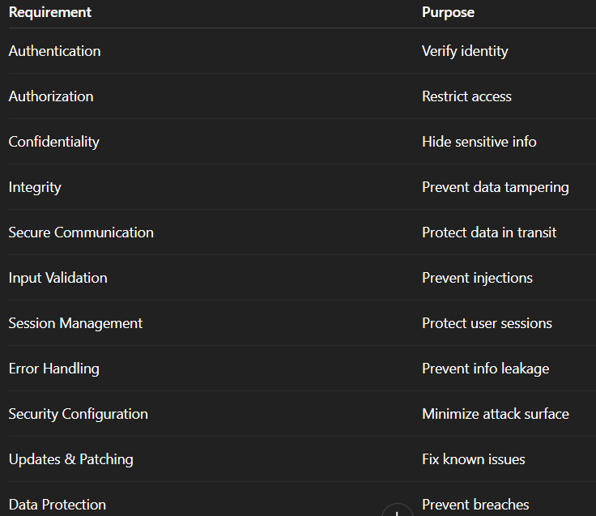

*User Authentication and Session management :-
Session management is the process of maintaining and controlling user sessions in a web application or system. It involves managing the interaction between a user and the system during a specific period.
This ensures that users’ identities and session data are protected. It helps protect user data, prevent unauthorized access, and mitigate session-related vulnerabilities such as session hijacking or session fixation attacks.

*Cookies :-
Cookies play a vital role in web applications, especially for user authentication, session management, and personalization. They are small pieces of data stored on the client’s browser and sent with every request to the server.
Cookies are small files which are stored on a user's computer. They are used to hold a modest amount of data specific to a particular client and website and can be accessed either by the web server or by the client computer.

*Penetration testing :-
Penetration testing serves as a pro-active measure to try identify vulnerabilities in services and organizations before other attackers can.
Penetration Testing is a simulated cyberattack performed on a computer system, web application, or network to evaluate its security. The goal is to identify and fix vulnerabilities before real attackers can exploit them.
Purpose –
- Identify vulnerabilities in systems, applications, and networks.
- Test effectiveness of security controls.
- Evaluate the impact of a successful exploit.
- Ensure compliance with standards (e.g., ISO 27001, PCI-DSS).
- Reduce risk of real-world attacks.

*SSH :-
SSH (Secure Shell) is a network protocol used to securely access and manage devices over an unsecured network. It provides encrypted communication between a client and a server, commonly used for remote login and command execution.
SSH is a cryptographic protocol that enables secure remote access to systems, allowing users to log into another computer over a network, execute commands, and transfer files – all securely.
Role of SSH –
- Secure remote access - SSH allows users and administrators to remotely log into servers and devices securely.
- Encrypted data transfer - SSH encrypts data between client and server, ensuring confidentiality of sensitive information such as passwords, commands, and files.
- Authorization and Authentication - SSH supports multiple authentication methods ensuring that only authorized users gain access.
- Secure file transfer - SSH enables secure file transfers using protocols like SCP (Secure Copy) and SFTP (SSH File Transfer Protocol).
- Port forwarding and tunnelling - SH can tunnel other protocols and applications securely through encrypted channels

*SSL :-
SSL (Secure Sockets Layer) is a cryptographic protocol designed to provide secure communication over a computer network, especially the internet. It ensures confidentiality, data integrity, and authentication between a client (usually a web browser) and a server.
SSL is a standard security technology that establishes an encrypted link between a web server and a browser, ensuring that all data passed between them remains private and integral.

Handshake Protocol is used to establish sessions. This protocol allows the client and server to authenticate each other by sending a series of messages to each other. Handshake protocol uses four phases to complete its cycle.
- Phase-1: In Phase-1 both Client and Server send hello-packets to each other. In this IP session, cipher suite and protocol version are exchanged for security purposes.
- Phase-2: Server sends it certificate and Server-key-exchange. The server end phase-2 by sending the Server-hello-end packet.
- Phase-3: In this phase, Client replies to the server by sending it certificate and Client-exchange-key.
- Phase-4: In Phase-4 Change Cipher Spec occurs and after this the Handshake Protocol ends.

*Phishing :-
A phishing attack is a type of cyberattack where attackers trick victims into revealing sensitive information like usernames, passwords, or credit card details, often by posing as legitimate entities. This is usually done through deceptive emails, text messages, or websites that appear to be from trusted sources. The goal is to get the victim to click on a malicious link, download harmful files, or provide personal information
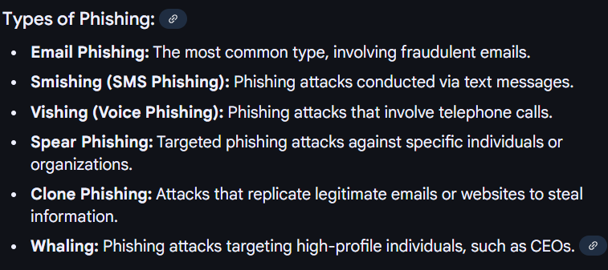

*HTTP vs HTTPs :-
